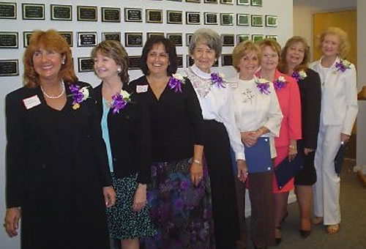

Cutline: (l-r) Linda Michalowski, Marilyn Dial, Connie Conti, Margaret Tucker, Deanna Hickenbotham, Anne Johnston, Kelly Humphrey and Marge Mann

2007 Honorees
Connie Conti, Marilyn Dial, Deanna Hickenbotham, Kelly Humphrey, Anne Johnston, Marge Mann, Linda Michalowski, and Margaret (Marge) Tucker.

